Vision Document  
[SmartHome+ : A Smart Home Platform]

# Introduction

The purpose of this document is to outline a vision for SmartHome+: A smart home platform that encompasses a wide spectrum of ideas and concepts about intelligent living. The document addresses the following:

* Identify and agree on the essential needs and expectations of end users from SmartHome+.
* Mapping the identified needs to implementable features within SmartHome+.
* Analyzing the current market dynamics and researching some already existing offerings in the domain of Smart Home Automation Solution.
* Propose some new off-the-self distinctive features currently missing in general within other existing products in the market.
* Identify limitation and assumption for proposed solution.
* Identify stakeholders and users.
* Identify the user environment.

The scope of this document is limited to user needs, environment, and desired solution.

# Positioning

## Problem Statement

|  |  |
| --- | --- |
| The problem of | * Disconnected devices and appliances * Unmonitored In-Home environment (temperature, air, and water quality) * Unmonitored In-House energy consumption * Home safety against unforeseen situations. * Decentralized media and entertainment devices. * Mundane day to day household activities. |
| Affects | * The home residents: * Adults * Children * Senior members * Pets |
| The impact of which is | * Time and effort wastage over repetitive tasks * Risk for home residents in the event of some exigency like flood, fire or intrusion. * Losing more money in bills due to inefficient energy usage * Losing out on a more comfortable and smarter lifestyle |
| A successful solution would be | Offers its users an automated and intelligent lifestyle in terms of their daily household routine by focusing an improving over the following six dimensions:   * Accessibility (an easy to use solution) * Environment Monitoring (better living conditions inside house) * Energy efficiency control (optimized energy utilization) * Enhanced security * Improved Media and entertainment experience * Automation of mundane household tasks |

## Product Position Statement

|  |  |
| --- | --- |
| For | Home-Residents |
| Who | Are finding it hard to manage, monitor and synchronize a variety of devices and automating daily tasks. |
| The [SmartHome+] | Is a Smart Home Automation platform |
| That | Enables its users to:   * Save both time and effort by automating daily routine tasks and enjoying more quality time with their families. * Monitor healthy and ambient living conditions within their homes. * Ensures efficient energy utilization to save costs on bills. * Provide safety and security measures for intrusion and other unforeseen emergency situations like fire and floods. * Provide meaningful recommendations towards optimizing their energy consumption * Synchronize various media and entertainment platforms and devices for a seamless and more unified experience. |
| Unlike | Other commercial solutions in the market that tend to support a small subset of smart devices. |
| Our product | Offer a more comprehensive, cost effective and an extensible solution that apart from supporting a bundled set of smart devices can also be customized by including smart devices manufactured by other third-party vendors. |
|  |  |

# Stakeholder Descriptions

## Stakeholder Summary

|  |  |  |
| --- | --- | --- |
| Name | Description | Responsibilities |
| Smart Solutions Inc | The owner of the project | * Provide a high-level product description * Monitors and manages the project * Finalizes different proposal * Approves budget * Provides feedback * Participate in User Acceptance Testing. |
| Users | Home-Residents who will be using the solution. | * Provide feedback and comments. * Suggest new features and modifications |
| Developers | The team responsible for eliciting requirements and developing the product. | * Requirement elicitation and analysis to come up with a Software Requirement Specification (SRS) document. * Designing, developing and testing the system. * Preparing documentation and user guides. * Post-delivery maintenance of the system. |
| External Smart Device Vendors | Third Party Vendors who would be manufacturing Smart devices that can easily pair with our solution | * Provide necessary device specific APIs/Interfaces that allows for a seamless device integration with SmartHome+. |

## User Environment

User can access the system both locally and remotely via interfaces like the Control Unit Touch Panel or an interactive mobile application. Local access also includes support for voice-based assistants to improve accessibility for elderly people or people with some vision related impairments. Remote access can be achieved using Mobile/Browser app. The system is self-evolving based on the user’s daily routines and would try to optimize the living condition and energy consumption based on household patterns and external sources like weather forecast feeds; however, user also can override the self-evolving mode and can switch to a manually controlled system at any point of time. Users will receive notifications through email and/or SMS concerning the status of the system. System will trigger alarms and send notifications when safety is compromised (Ex: Fire, flood, intrusion). Other hardware and OS related system information has been shared in section 5 of the document.

# Product Overview

## Product Perspective

The SmartHome+ is a home automation solution which integrates various IoTs in a household through a central controller to automate daily home tasks, enhance accessibility to the IoTs, provide home security and reduce energy waste.

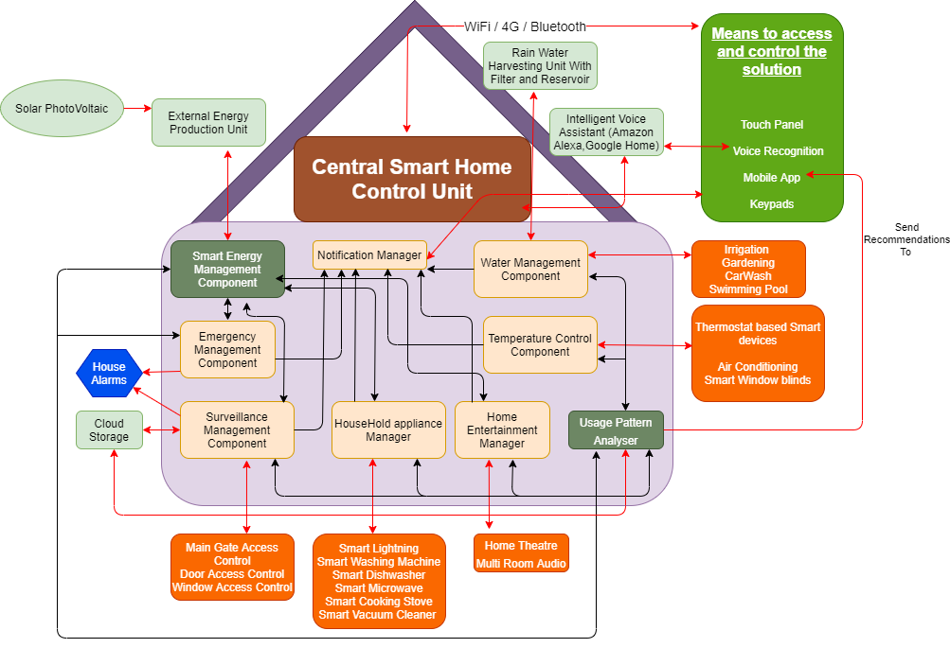

* **Central Smart Home Control Unit** comprises of various subcomponents each handling a specific dimension dedicated towards providing an overall smart living experience.
* **Smart Energy Management Subcomponent** apart from managing and optimizing energy usage also interfaces to external energy generation sources
* **Usage Pattern Analyzer** is the key component offering a Self-Evolving mode to the solution by collecting usage data from various subcomponents and trying to optimize their utility by learning patterns from the collected data. Besides it also makes meaningful lifestyle recommendations to the end users over the mobile app interface.
* **Red Colored Arrows** represent links going out from Central Control Unit to outside environment (User Interfaces, Smart Devices, Alarms, and Other Systems)
* **Black Colored Arrows** represent links internal to the Central Control Unit.

## Assumptions and Dependencies

|  |  |
| --- | --- |
| Assumptions | Dependencies |
| Controller and the smart devices both provide support for connectivity using Wi-Fi/Bluetooth | Communication between the devices and controller happens via Wi-Fi/Bluetooth |
| Internet connectivity is available for remote access. | Mobile/browser apps use the Internet to communicate with the controller. |
| In cases where the Smart Devices is manufactured by some third party vendor, necessary Smart Device APIs are exposed for the controller to connect to it. | Controller needs to monitor and control the devices using APIs. |
| Environment is free from poor Wi-Fi signal strengths, interference and any other signal jamming from external devices. | Controller and devices communicate via Wi-Fi/Bluetooth. |
| Central Smart Home+ users are willing to give access to analyze and monitor their daily lifestyle patterns. | This is required for the solution to make meaningful recommendations and also optimize the energy utilization. |

## Needs and Features

|  |  |  |  |
| --- | --- | --- | --- |
| Need | Priority | Features | Planned Release |
| Mode of access/control | 1 | Local access to the controller using Touch panel / Keypad or Voice based assistants. | V1.0 |
|  | Remote Internet based Access. | V1.0 |
| Security Measures | 1 | Surveillance Cameras in the home. | V1.0 |
| 1 | Main gate access | V1.0 |
| 1 | Door Access Control | V1.0 |
| 1 | Home Alarms | V1.0 |
| 1 | Intrusion Detection | V1.0 |
| Energy Management | 2 | Smart irrigation and automated gardening. | V1.0 |
| Energy Management | 2 | Automated swimming pool Maintenance | V1.1 |
| Energy Management | 2 | Automated window blinds | V1.0 |
| Energy Management | 3 | Automated Rain Water Harvesting | V1.0 |
| Energy Management | 3 | Time of Day usage Analytics | V1.0 |
| Energy Management | 3 | Air flow monitoring | V1.0 |
| Energy Management | 3 | Managing Alternative Energy harness systems | V1.1 |
| Emergency Detection | 1 | Smoke/Gas leakage Detection. | V1.0 |
| Emergency Detection | 1 | CO level detection. | V1.0 |
| Emergency Detection | 1 | Water leakages / Water level detection. | V1.0 |
| Household Automation | 1 | Automated Air Conditioning system | V1.0 |
| Household Automation | 1 | Automation of the Lightning of the room | V1.0 |
| Household Automation | 3 | |  | | --- | | Automation of cleaning activities (Like Laundry and Dishwashing) | | Automation in cooking ( Like a smart microwave) | | V1.0 |
| Household Automation | 3 | |  | | --- | | Smart Home theater | | Multi room audio | | V1.0 |
| Emergency Notification | 1 | SMS | V1.0 |
| Emergency Notification | 1 | Email | V1.0 |
| Mode of connectivity | 1 | WI-FI   |  | | --- | | 4G-LTE/5G |   Bluetooth | V1.0 |
| Mode of authorization | 1 | Passcode   |  | | --- | | Fingerprint |   Facial Recognition | V1.0 |
| Modes of Operation for the devices to work | 1 | |  | | --- | | User control mode | | Self-Evolving mode | | V1.0 |
| Storage | 1 | |  | | --- | | Local Storage | | Cloud Storage | | V1.0 |
| Routine Activities | 4 | Kitchen Inventory Management. | V1.2 |
| Routine Activities | 4 | Automated feeding plan for pets. | V1.0 |
| Routine Activities | 4 | Medicine Inventory Management. | V1.1 |
| Expandable Controller | 1 | Simple interface to connect to third party / new devices. | V1.0 |
| User Mode of Operation | 1 | |  | | --- | | Single user mode | | Multi user mode | | V1.0 |
| Safety Measures |  | |  | | --- | | Automated call to 911 in case of intrusion/break-in | | Automated call to fire control department | | V1.1 |

## Alternatives and Competition

* **ADT Smart homes:**

ADT is a 145 years old company which offers some of the smartest home solutions available in the market. ADT is a customizable, pro-installed home security system with continuous monitoring. ADT has evolved beyond home monitoring into connected home automation appliances, devices and detectors, including through popular smart home assistants Amazon Alexa and Google Home.

**Pros:**

* + Five Diamond Certification from TMA (The Monitoring Services) and ULC Certification for the outstanding Monitoring Services.
  + 125 years of Security Expertise.
  + 24/7 professional monitoring.
  + Temperature fluctuation protection.
  + CO Monitoring.
  + Fire Monitoring.
  + Flood protection.
  + 6-Month Money-Back Guarantee if any issues.

**Cons:**

* + Complicated Security Systems.
  + ADT uses third party devices which can sometimes affect the quality of the service.
  + 36 months contract.
* **Bell Canada**:

Leveraging the power of our world-class wireless and fiber networks, BCE delivers a wide range of service innovations to consumers, businesses and government customers across Canada including LTE Advanced, Fiber Internet and TV, Wireless Home Internet, cloud and data hosting, IP voice and collaboration, Connected Cars, Smart Cities and Internet of Things. Bell Smart Home is for people who are already using Bell Canada for TV, Internet, and Phone who want to bundle.

**Pros:**

* + Save money by bundling.
  + Affordable.

**Cons**:

* + Complicated Security Systems.
  + Poor Customer Service.

# Other Product Requirements

5.1 Hardware requirements:

* The controller and the devices have the required hardware to enable communication using Wi-Fi/Bluetooth and ZWAVE, ZIGBEE.
* Controller has provision for SIM to enable 4G and WAN ports for Broadband connectivity.
* Controller is equipped with RAM and SD card to store local information.
* Controller can connect and run on battery backup.
* Rechargeable batteries supported by the controller.

5.2 Platform requirements:

* Controller runs on LINUX and supports the JAVA environment. The firmware will be implemented in Java.
* Firmware/Software upgrades will happen over Broadband (primary) or 4G (secondary).

5.3 Performance requirements:

* 24 hours battery backup in case of power failure.
* Access to 4G during broadband failure.
* Expected latency to send and receive commands to the devices is < 1 second.
* Expected latency to receiving notifications is 1-2 seconds.
* Ability to detect malfunctioning devices and power loss.
* Expected latency between cloud server and controller is < 1 second.

5.4 Security

All transmissions to and from the controller are encrypted to ensure privacy and data integrity. Authentication modes to the system include password, voice and face recognition and only authorized users can monitor and control the system.

5.5 Standards:

Devices and controller are compliant with CE (European Conformity) and FCC (Federal Communications Commission) standards and other required local regulatory services. Additionally, the product will be UL certified

5.6 Documentation:

User manual and installation documentation are produced which instructs on recommended and safe installation and usage of the system.

5.7 Installation:

Users will have the opportunity to install the system using a usable, self-guided interface.

5.8 Risk:

* The system will not function when there is a power failure and when the battery runs out.
* The system will not be remotely accessible in case of broadband failure and poor 4G connectivity.

Glossary:

* Controller -
* Devices -
* IoT -
* Firmware –
* ZWAVE –
* ZIGBEE -

References:

[1] IoTAS Wireless Testing Group [Online]. Available: <https://www.iotas.co.uk/ce-fcc-regulatory-services/>

[2] Bell Canada Enterprise [Online. Available: https://www.bce.ca/

[3] [Ludovic Rembert](https://privacycanada.net/contact-us/) (May 25, 2020), Best Home Security System [Online]. Available:

https://privacycanada.net/best-home-security-system/

[4] Christopher George (Mar. 12, 2020), The Pros and Cons of ADT Home Security [Online]. Available:

<https://www.familyhandyman.com/article/pros-cons-adt-home-security/>

[5] IBM Knowledge Center [Online], Available: <https://www.ibm.com/support/knowledgecenter/SSYMRC_7.0.1/com.ibm.rational.rrm.help.doc/topics/r_vision_doc.html>